Exercise: REST Services and AJAX
The following tasks do not have tests in the Judge system. They are for practice.
Working with Remote Data
For the solution of some of the following tasks, you will need to use an up-to-date version of the local REST service, provided in the lesson’s resources archive. You can read the documentation here.
- REST Countries
NOTE: Install "Postman" REST Client to ease your tasks.
- Manually compile an HTTP (as text) request for retrieving information about Bulgaria;
- Use Postman to make the same request;
- Make a request that retrieving only the fields name, capital, region, population for the country Italy.
- Make a request that takes all German-speaking countries.
Your first task is to get detailed information about Bulgaria.
- Send a "GET" request to the link given below.
REQUEST:
https://restcountries.com/v3.1/name/Bulgaria
RESPONSE:
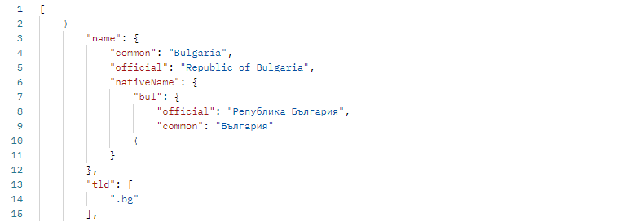
Each API has documentation, where you can see how to use the API. You can find the documentation of this API here: https://restcountries.com/
- Now try to filter only specific fields of the information about Italy. Send a GET request with the needed parameter to get a response only with this information about the country:
- name, capital, region and population;
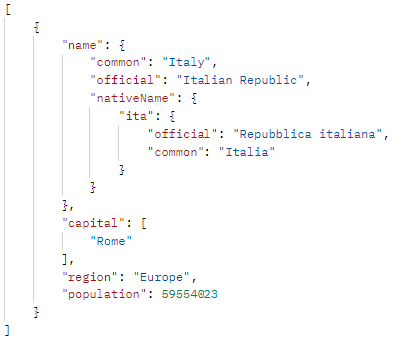
- There is a way to get a response holding all the countries that use the Euro as their currency. Send a GET request to retrieve the information for these countries (for example, Germany, France, Italy, Spain, etc.), but filter the response to have only their names and subregion.
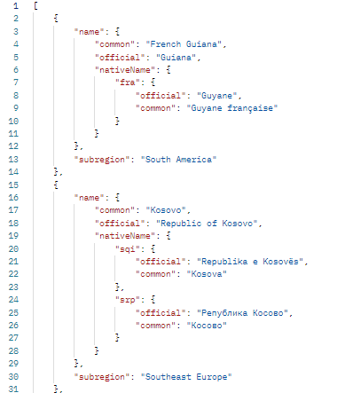

Bus Stop
Perform an HTTP request that displays arrival times for all buses by a given bus stop ID.
- GET: http://localhost:3030/jsonstore/bus/businfo/:busId
You will receive a JSON object in the format:
stopID: {
name: stopName,
buses: { busId: time, … }
}
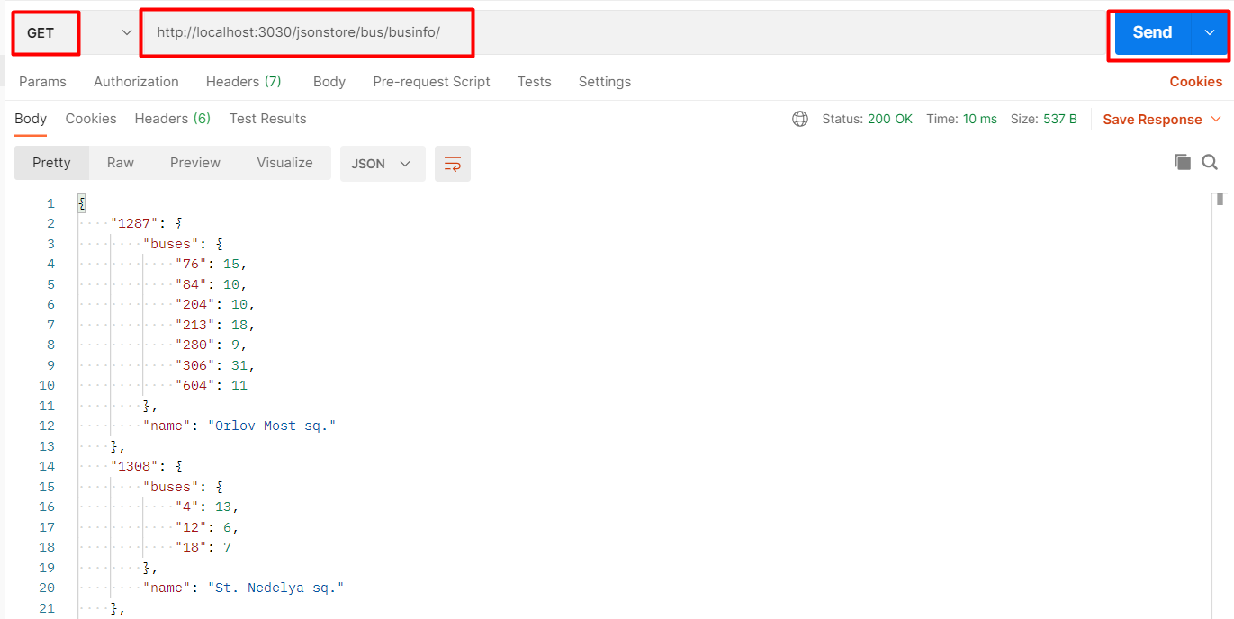
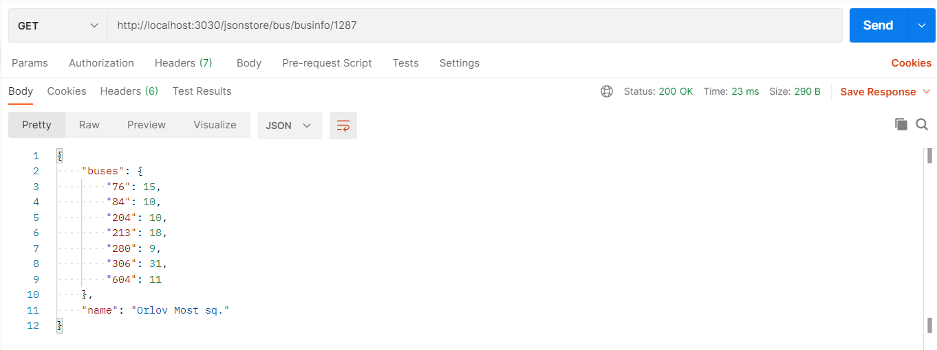

Hints
The webhost will respond with valid data to IDs 1287, 1308, 1327 and 2334.
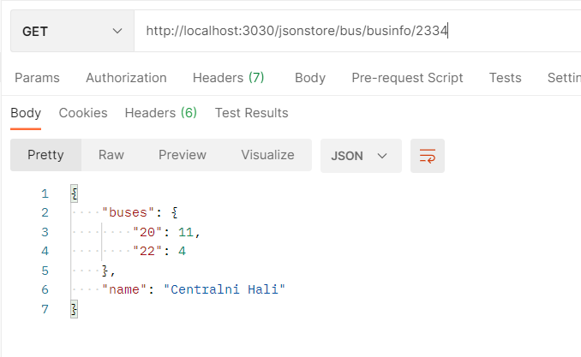

Phonebook GET
Perform an HTTP request that show people’s names, their phones and _id.
GET requests: http://localhost:3030/jsonstore/phonebook
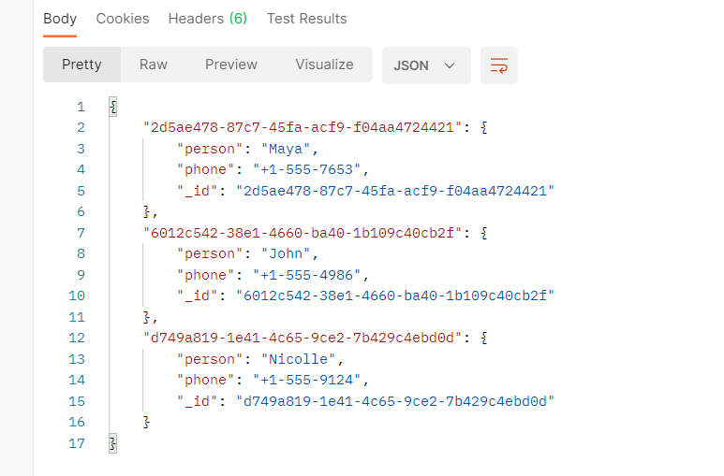

Phonebook POST
Create two different requests with POST request in Postman. The data sent in a POST request should be a valid JSON object, containing properties person and phone. Example format:
{
"person": "<person>",
"phone": "<phone>"
}
POST: http://localhost:3030/jsonstore/phonebook

Store
Use the link below to get, post, put and delete request in Postman. Send five types of requests supported by the API.
- https://fakestoreapi.com/docs

- GET REQUEST
Use the link in Full Route section to get all store items data and single item data.
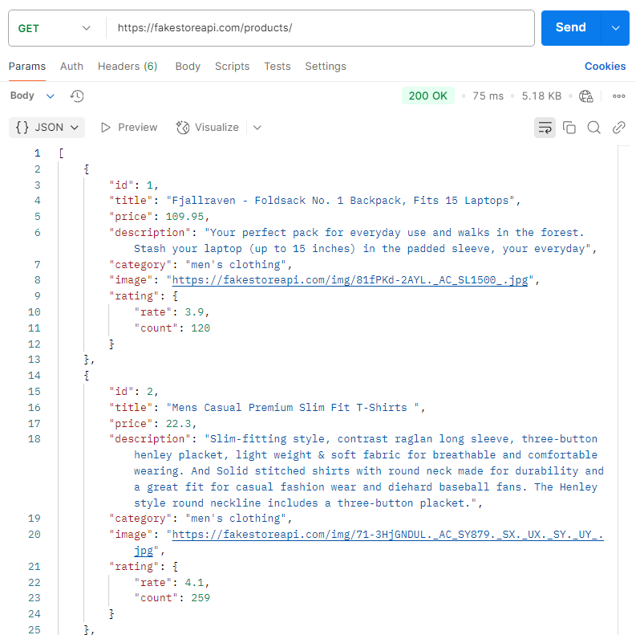
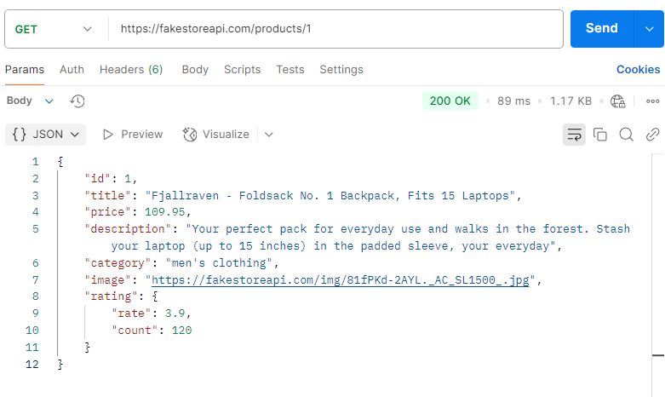

- POST REQUEST
Create new record in database
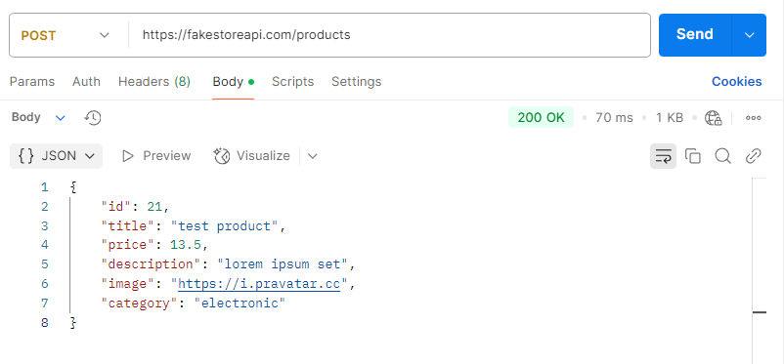
- PUT REQUEST
Update an item record
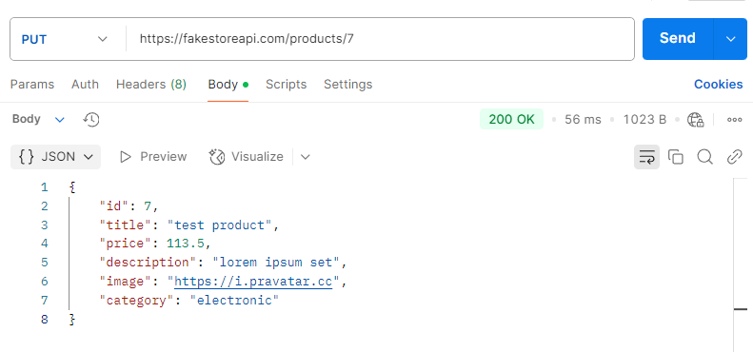
- DELETE REQUEST
Delete an item record
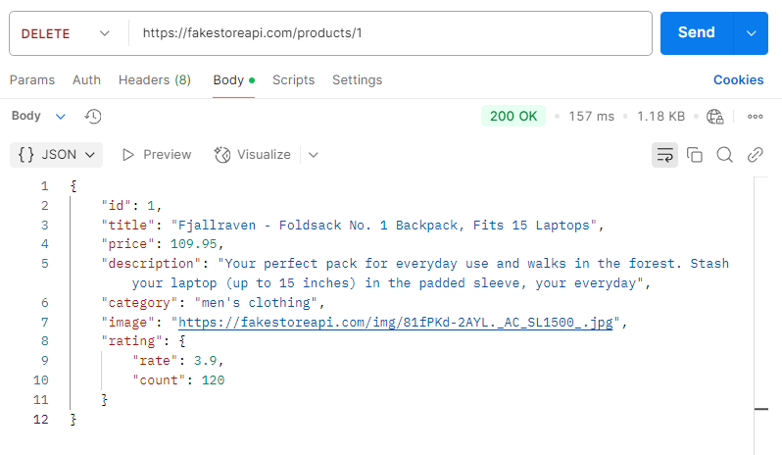

Firebase App
Create Firebase application to configure a collection. In that case your collection will be with books and authors.
Use postman to create, read, delete entries from the collection.
Books Genre | Title | Author
Non-Fiction | Get Out of Your Head: Stopping the Spiral of Toxic Thoughts: | Jennie Allen
 | Trust: America’s Best Chance | Pete Buttigieg
 | When Breath Becomes Air | Paul Kalanithi
Romance | It Ends With Us | Colleen Hoover
 | The Proposal | Jasmine Guillory
Thrillers | Gone Girl | Gillian Flynn
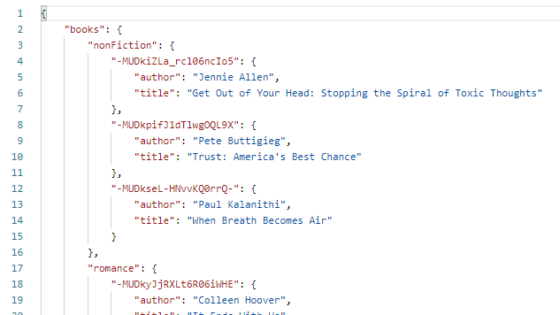
- Use JS-Applications-Remote-Databases-Guide.

Backendless App
Create Backendless music application. It has to contain title and singer.
Use Postman to create, read, delete entries from collection.
Singer | Title
Eminem | Cinderella Man
Alan Walker | Faded
Dove Cameron | We Belong
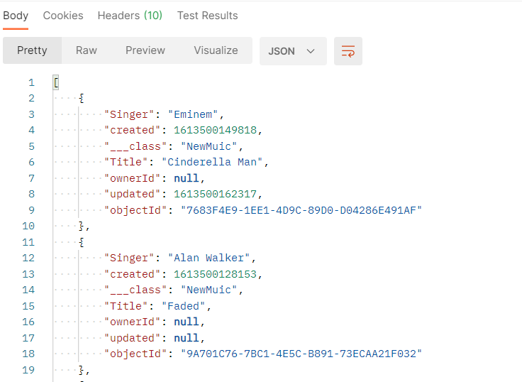
- Use JS-Applications-Remote-Databases-Guide.

Back4App App
Create Back4App App for students. It has to contain first name, last name and average grade.
Use Postman to create, read, delete entries from collection.
First Name | Last Name | Average Grade
James | Christopher | 5.70
Barbara | Smith | 4.90
Sarah | Johnson | 5.90
William | Miller | 3.30
Matthew | Taylor | 4.10
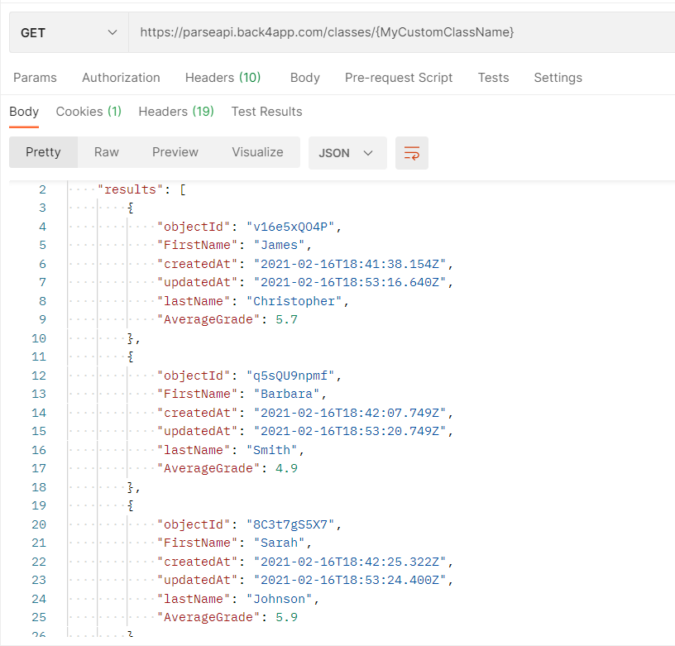
- In Postman you must add headers.
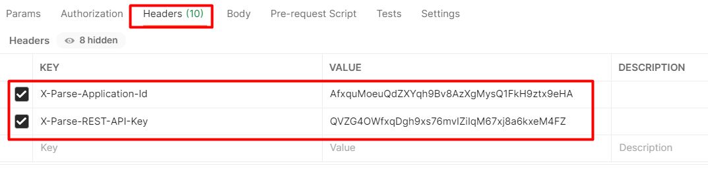
- Use JS-Applications-Remote-Databases-Guide.

